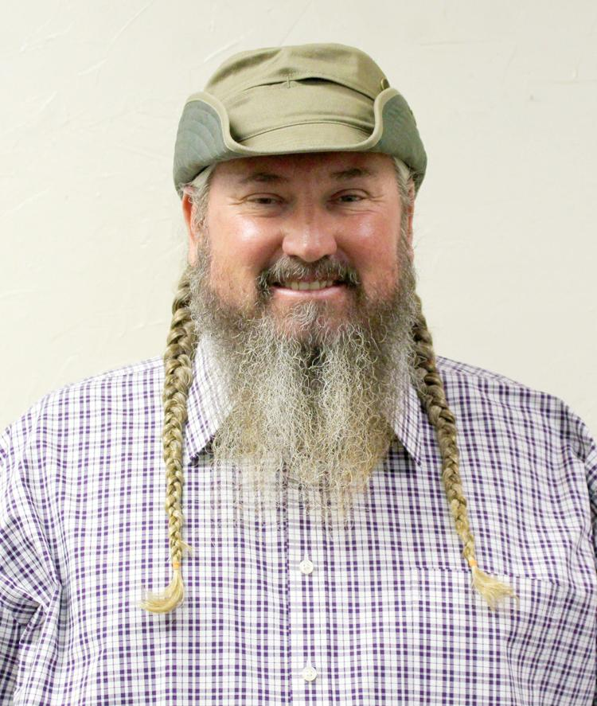
Another candidate has filed in the race for Parker County sheriff and Russell Hess, 48, Libertarian, said he has a plan to bring the county together and save taxpayer dollars.
Hess filed on Nov. 18 and has been self-employed for the majority of his life.
“I grew up in Ranger, Texas, went to school there, and then I moved around when I was about 18-19 — my dad and I went into the convenience store business. I was in the convenience store business for several years, I think from 1990 to 2000,” Hess said. “I’ve been self-employed my whole life. I got into the shipping container business and have been doing that ever since 2000 and I’ve had a gun store for two or three years, so that’s pretty much what I’m doing now.”
Hess said the reason he’s running for sheriff is to bring the county together, make sure every person is treated fairly and take care of the people.
“I would like to bring Parker County together as one. The Constitution says every man, woman and child is created the same and that’s how I want to treat people. I think for years, not only in Parker County but all counties, it’s been divided. The sheriff is supposed to take care of We the People and you can’t divide — whether someone is Republican, Democrat, Libertarian, whatever — we can’t keep dividing people,” Hess said. I think our ultimate goal should be freedom and I’m going to be a constitutional sheriff. A lot of people that run for office say they’re going to be for the Constitution, but they violate the Constitution on a daily basis and I’m not going to be that guy. I want to make sure everyone’s rights are upheld no matter what race you are — black, brown, white — and I want to make sure everyone is treated fairly. I want people to know that if you happen to get arrested, from the time of your arrest to the time that you’re let out of jail, you’ll be treated with the utmost dignity and respect.”
Hess said this is the first time he’s running for office and one of his platforms will focus on the second amendment.
“People’s rights have been violated forever and the second amendment says that it will not be infringed on. For example, I can’t walk into the courthouse with my firearm. They’ve made a code, it’s really not a law, and that violates my constitutional rights and other people’s constitutional rights,” Hess said. “As the sheriff, I give people my word that there will not be any firearm arrests in Parker County. If you can take an AR-15 with a 16-inch barrel and cut one-inch off that barrel, that’s 10 years in a federal penitentiary, which is unconstitutional. People don’t know the difference, but I know the difference.”
Hess said the second issue he will focus on is the unconstitutional drug laws.
“The drugs are worse now than they were, so the War on Drugs is not working. I have a plan and when I’m elected sheriff, I believe I can fix the problem with the help of cannabis — I think I can get people off hard drugs through cannabis. Arresting people and putting them in jail does not solve the problem because I have friends that have been to prison two or three times for drugs and it never solved the problem,” Hess said. “When I’m elected sheriff I want to move forward and bring new ideas in. The old ideas haven’t worked. I want people to know exactly what they’re going to get when they vote for me and we will be growing cannabis in Parker County.”
In his 48 years, Hess said he’s never done drugs and hasn’t had a drink in about 10 years and the current system in place for handling drugs isn’t working.
“The current situation of arresting people and putting them in jail for 99 years for drugs and then arresting somebody for murder and giving them 10 years, something’s wrong. I think I can grow marijuana in Parker County, make sure it’s pure and not laced with anything, and if folks will come up to the jail and take a urine test and as long as they don’t test positive for any hard substance other than marijuana, I will give them a weeks supply of marijuana for free,” Hess said. “So many people are afraid of being arrested. I watched a guy in Mineral Wells die of cancer because he was afraid to break the law, which is not constitutional. Nobody will stand up, but I’m going to stand up and be for the people and try to help with their problems.”
Hess said he would also hire people to help with mental health issues in the jail.
“I’m willing to cut my pay, zero pay, and I think with the least amount of people getting arrested, I will save the taxpayers thousands and thousands of tax dollars,” Hess said. “Libertarians believe in less government and the government is robbing us blind.”
Documentation was provided to the Weatherford Democrat regarding the selling of Hess’ property to levy judgment in regards to funds owed to First Financial Bank in Palo Pinto County, but Hess said he could not legally speak on the matter and that it is in the process of being taken care of at this time.
“I signed a non-disclosure agreement with the bank and they signed one as well, so we’re not supposed to talk about anything with that,” Hess said. “[It’s] in the process of being resolved.”
Additionally in the race for Parker County sheriff, Kennedale Police Captain Darrell Hull, 47, Republican, filed on Nov. 13 to run for sheriff. Hull — who has been in law enforcement for 25 years — declined to comment about Hess running for sheriff, but said it’s time for change.
“Our current sheriff has been in law enforcement for over 60 years and has had a great career,” Hull said. “I believe it’s time for a change and to move forward into our future. I have the experience and knowledge to move forward and improve the quality of life for Parker County. I will do this and keep our family values and western heritage identity hat we are so proud of.”
Parker County Sheriff Larry Fowler is seeking another term as sheriff, saying the Parker County Sheriff’s Office has seen great success since he took office.
“When I took office the needs of this sheriff’s office were obvious. It was quite a challenge to get where we are today and to be quite honest about it, I want another term because I want to enjoy this,” Fowler said in a previous interview. “We’ve had great success and that may sound a little simplistic, but it’s the truth and I’m at a point now where I’m enjoying what we’ve accomplished.”
Fowler declined to make comments about Hull or Hess running for the position.

