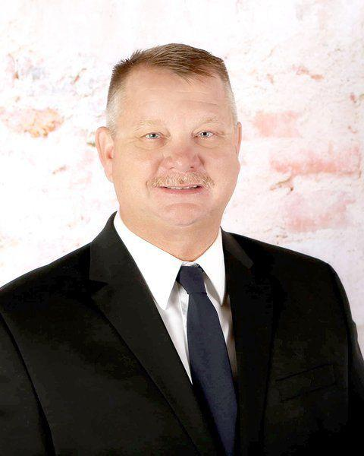

With more than 25 years experience in law enforcement, Darrell Hull has decided to throw his hat in the ring and run for sheriff.

Hull, 47, grew up in Parker County and attended Weatherford ISD schools. He still lives in the county today and is currently the captain at the Kennedale Police Department. Hull started his career in law enforcement in 1993 as a Springtown reserve officer, joined the Weatherford Police Department a year later and then went to the Kennedale department in 1996.

“I’ve been there for the last 23 years and with that I’ve had interactions with officers that are still here in Weatherford and Springtown, and surrounding agencies. I like being involved in our communities and I want to come back and be a part of it — not only on a personal level, but a professional level,” Hull said. “I think a lot of people in Parker County are looking for change, I think they desire change and I think I can be that.”

Parker County Sheriff Larry Fowler announced he would seek another term, saying the Parker County Sheriff’s Office has had great success since he took office.

“When I took office the needs of this sheriff’s office were obvious. It was quite a challenge to get where we are today and to be quite honest about it, I want another term because I want to enjoy this,” Fowler said. “We’ve had great success and that may sound a little simplistic, but it’s the truth and I’m at a point now where I’m enjoying what we’ve accomplished.”

Hull said his goals include professionalism, accountability and integrity; to provide the highest level of service while making use of the most efficient and effective management and budgeting techniques available; reduction in major crimes in building relationship with an emphasis on crime prevention and education; build a partnership with other local agencies; seek local, state and federal funding for community outreach; and improve the safety and security of Parker County residents.

“I think those are goals we can meet within a four-year term. There are a lot of things I don’t know about the department, just what I’ve heard and of course some of them are good and some of them are bad, but I think one of the things about leadership is that there are good and bad things,” Hull said. “When you’re on the outside, sometimes it’s hard to see it or understand it, and I think there are a lot of issues that need to be addressed, but again, we’re on the outside so we don’t know what’s going on on the inside. Our citizens are wanting transparency, they’re demanding it, and I think that’s one of the things I can improve on — being open and transparent, and being able to share that with everybody.”

Hull said he got into law enforcement because he enjoys helping and interacting with the public.

“I think the No. 1 thing is just being involved and helping people, being able to interact, and more than anything just being an influence of doing the right thing,” Hull said. “I’ve been a school resource officer and have had students come up to me five or six years later thanking me for being there. I think it’s important to listen. Sometimes we don’t have to say anything, just sit there and listen, and that helps out a lot.”

As with Fowler, Hull will also be running as a Republican.

